FMX Mobile Application Development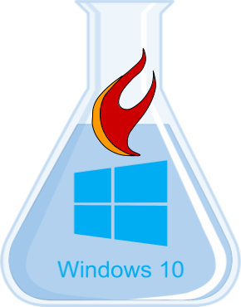

Hello **FireMonkey**

Lab Exercise

* Create a FireMonkey app for Windows
* Add a TTabControl, then right-click and “Add TTabltem”
* Include TLabel, TButton, TEdit, & TListBox on one of the TTabItems
* Notice TLabel & TButton have **Text** instead of **Caption** properties
* Notice the TTabControl has **TabPosition** of **PlatformDefault**
* In the OnClick event handler add the following code:
  + ListBox1.Items.Add**(**Edit1.Text**)**;
* Compile and run your app on Windows